**MICROSERVICES CASE STUDY**

1. **Books-Exchange Service**

The service is created with H2 database.

Created the table:

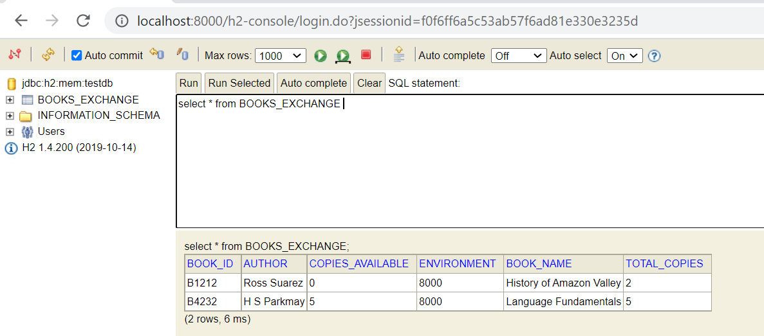

The service:

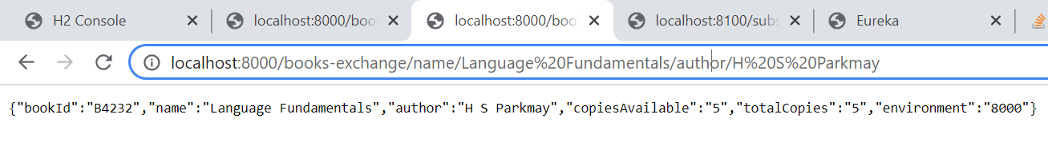

1. **Subscription Service**

The service is created for book subscription and table is created:

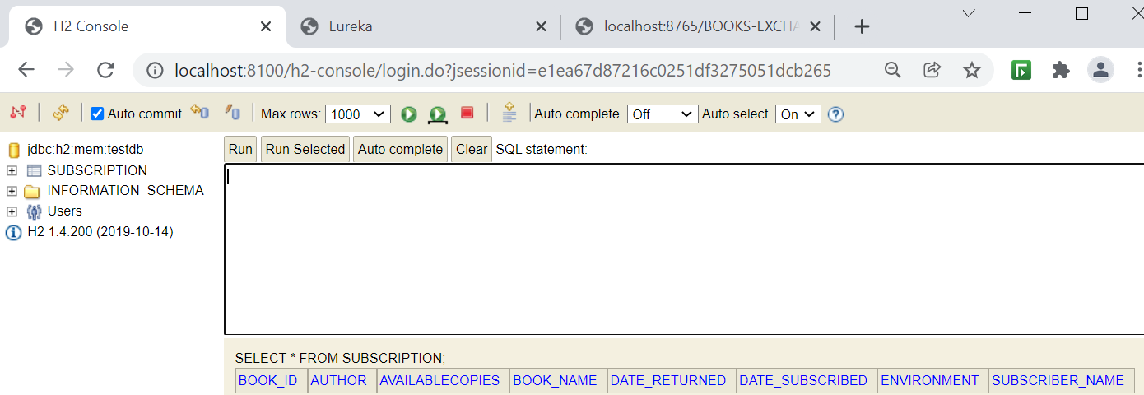

Book Service is called in controller of subscription service:

ResponseEntity<Subscription> responseEntity= **new** RestTemplate().getForEntity("http://localhost:8000/books-exchange/name/{name}/author/{author}", Subscription.**class**, uriVariables);

1. **Implement Feign**

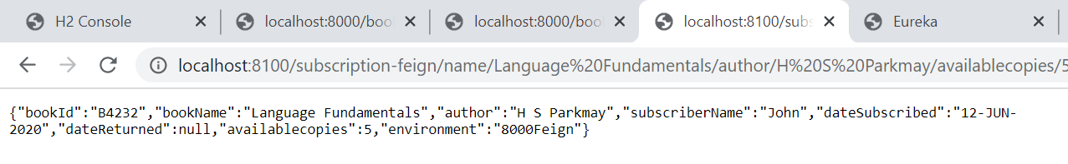

1. **Naming Service**

This service is created to implement Eureka server and other service we created are registered with Eureka:

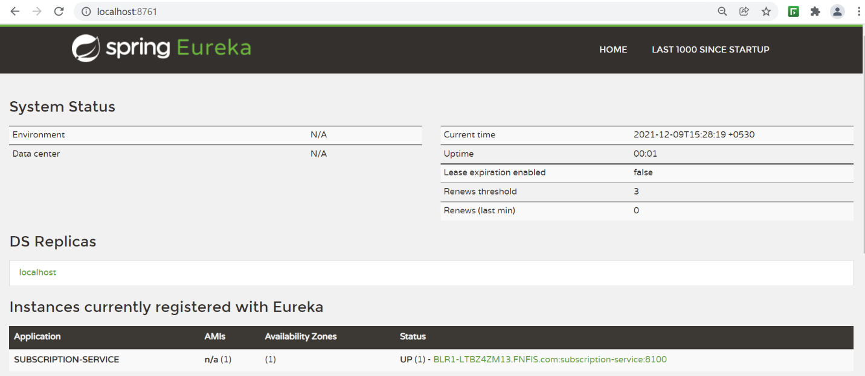

1. **Api-Gateway:**

This project is created to implement gateway, added to naming-service to Eureka server:

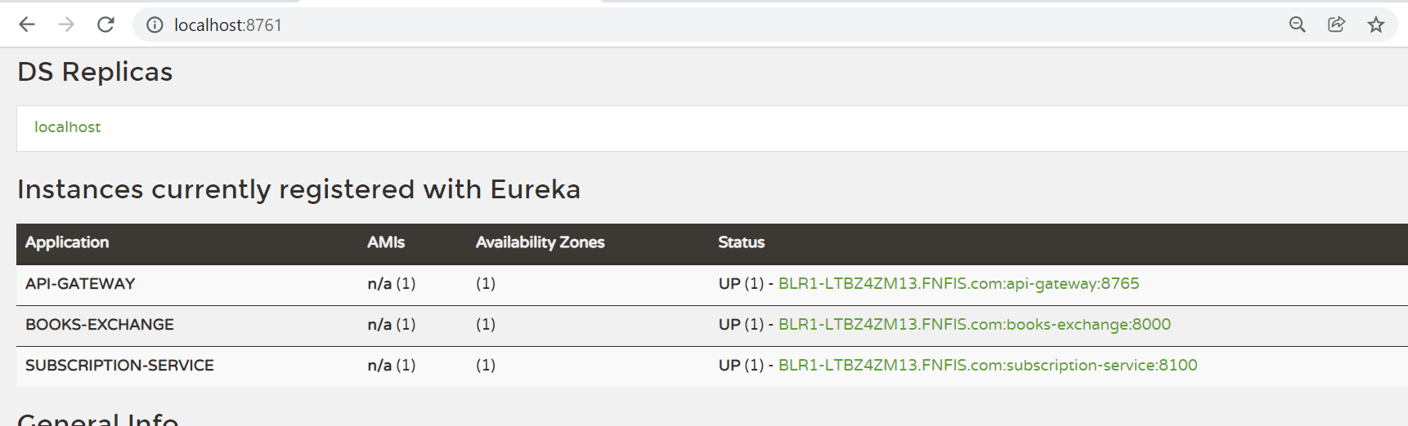

**All the services created discovery and registration is done.**